LEZIONE O3-03 pt.2
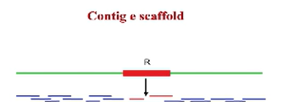
The more convenient approach was the SHOTGUN.
In the range of 1000 base pair, we will find a repetition.

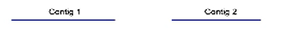

We can assemble this sequence very easily in a Contig 1, and Conting 2. Once we are sequencing the repetition, we will run into ambiguity. We will have a hole in the sequences, with no possibility of merging contig 1 and 2. The trick WHICH was invented to go around this problem was to use TWO different size of clones: SMALL and BIG.
For small fragments, the range of Sanger sequencing allowed to sequence all clone, no matter how much sequences obtained from each piece.
For big clones, we talk about the order of 20.000 base pairs. It was sequences the extremities of the clone.
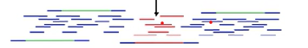
This clone has a unique sequence, the green one. Is unknow, but we can recover by the other fragments allying with the big clone. The extremity of this clone is nicely incorporated into the sequence of contig: just contribute of the assembly of Contig 1. When we run in red one, it is extremely helpful because one part is in the unique sequence, allying with contig 1. The other with contig 2, so we can join them together.

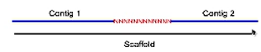
SCAFFOLD: high order object.

A Scaffold is a sequence in which we know the non-repetitive part. IN the case of the repetitive part, we don’t know the red sequence in the middle. But we know there is a hole. To fix it, we sequence the red one.
This hole became progressively fixed; in 2005 we had high quality sequence. The disadvantage of shotgun is that we need to sequence much more of the minimum to obtain a complete sequence. This is NOT a disadvantage. It allows to refund quality of sequence.
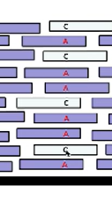
When we must assemble a sequence and we have these differences, we have 2 possibilities:
- It can be a sequencing error, 1% of the sequence
- Can be a real variant: we expect a person to be heterozygote, we expect to find the same base on several independent fragments, 50%.

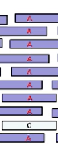 If we run into this situation, the “C” is easily filtered out as a sequencing error, is much less than 50% that we expected in case of a real variant. By using this redundant reading of sequence, we correct the error. This correction allows us to produce a sequence which has an accuracy much higher than 99%. In order to obtain a usable sequence, it must be accurate at 99,99%, to be capable of consistently and reliably identifying differences in population in order of 1 to 1000 magnitude. When we use SHOTGUN, we find sequencing error, expecting it to be randomly distributed.
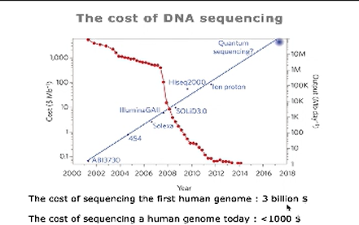
The cost dropped down thanks to second generation technologies.
We don’t need them anymore to manipulate DNA using bacteria clones.
To store data on hard disk is more expensive than obtaining data.

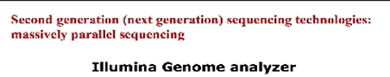

We take a blood sample, we extract the DNA and the first step is fragmentation of DNA/DNA breaking. We have fragments, broken and denatured. The extreme of the molecules is coloured, because they are artificial. We have NO cloning by attaching DNA to plasmids. We need to modify the ENDs of DNA molecules, needing to anneal some primer. We can sequence the unknow only starting from known point. This approach too is based on oligonucleotide. We start from single molecule, fragment. Also, in this approach we cannot sequence single molecules. We need to produce a clonal population starting from single molecules. The production of clonal population is not done from using natural system, but on a solid surface, using a related procedure to polymers chain reaction.
The extreme of the molecules is modified by two different sequences: P5 and P7. Everything is done in the surface of flow cells. There is a laminar liquid flow.
Multiplexing: we can analyse more than one sample. We can analyse DNA from 8 different individuals.
Every time we increase the number of samples we decrease the number of sequences we obtain per sample.
In this flow cells there are covalently attached DNA sequences. There are oligonucleotides, they are used to hybridize with the molecule that we put in the flow cell. We have these single molecules. The molecules to be sequenced are very sparse considering the density of oligonucleotide. Each molecule produces a clonal population, all the same but anchored very closed each other on the solid surface.
FIRST STEP: HYBRIDIZATION. Oligonucleotide is attached on the bottom of the plate, then we have a single string of DNA molecule. There are unknown sequences and the adaptors.
After ANNEALING, the ends are DNA polymers. We obtain new molecules complementary to the template, fiscally attached to the surface.
From one single molecule, we obtain a SPOT of DNA molecules, chemically anchored to the substrate. After generated the clonal population, it comes the sequencing.
The generation of data and reading of sequence is based on a cyclic procedure. In every time in every circle, we incorporate the nucleotide and the complementary nucleotide is a terminator. The reaction stops. Every spot is marked by a different colour.
Respect Sanger Method, this terminator are REVERSABLE, allowing the next corporation.
In other techniques we don’t have fluorochromes and terminators.
Paired sequencing data: we will having dataset information about the two different extremes of single DNA molecule. It has implications for data analysis.
Unpaired sequencing data.
After sequencing, we obtain aligned fragments. We go to row data to sequencing.
SECOND GENERATION TECHNOLOGIES
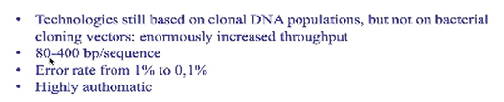
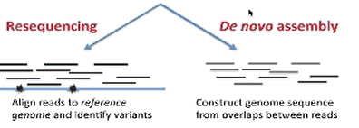

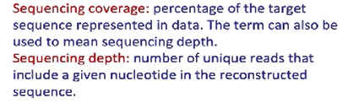
.

In 2001 “Nature” paper published, describing the first draft of human genome. = transition to pre-genomic to post-genomic era.
2015 “1.000 genome project” . Done to capture most of the variability in the human population (different ethnicities and healthy people).
2016 “10.000 project”.
There are 6.000 genetic disorders. 2/3% of global population is interested.
Now we can diagnose the predisposition before the first child is born.
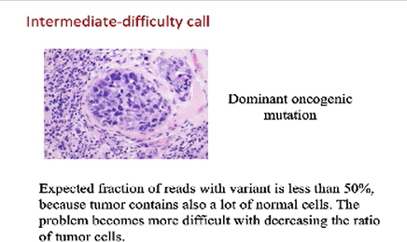
When we are sequencing the genome, there are calls that can be difficult depending on rarity of variance that we are looking at.
If the problem is analyse cancer genus, we take DNA. The cells contain mutation.
If we sequence all sample, the tumour DNA is a low percentage.

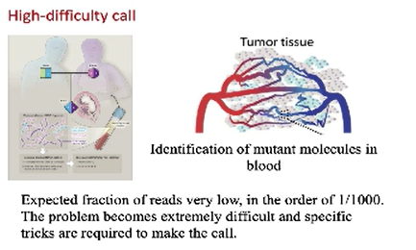
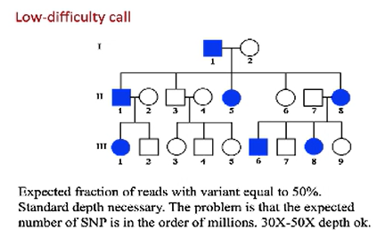


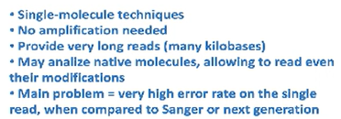

Maybe the second generation is better in accuracy than the third.
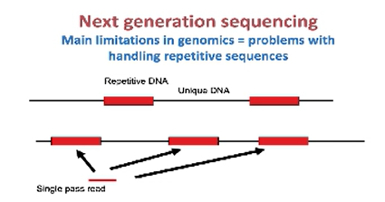
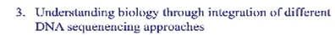
From DNA we go to RNA. Making this in our cells, is a jump of complexity. One gene can give many different transcripts.

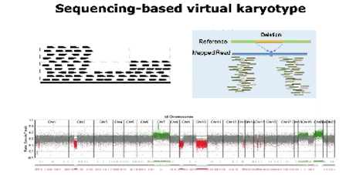
There are regions of DNA that are deleted, or duplicated (copy number variations).
If a region of genome is duplicated, the number of reads that are coming from that region will be doubled than expected. If deleted, we will have less than expected.

Sequence can also tell us about other events, like “TRANSLOCATION”, one of the most dramatic that cause oncogenic transformation. A piece of chromosome is attached to another chromosome. It may destroy tumour suppressing genes.
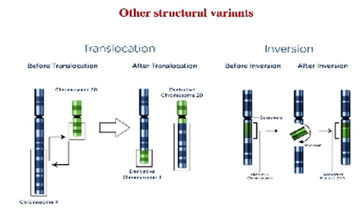
With inversion, we can break genes and activate/disactivate oncogene. There is no gain or loss of genetic information. It changes the arrangement within the chromosome.

To know what cells are doing, we look to the transcriptome cells producing and which quality/quantity.
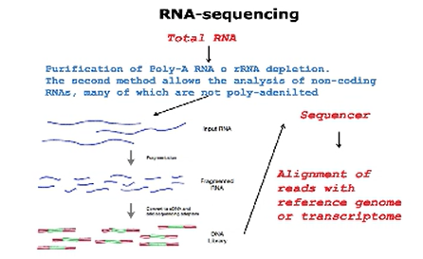
Today, we can analyse the protein that are attached to DNA. We only need an antibody that recognizes the protein. Antibody are complementary molecules. We break anything, destroy nucleus, don’t destroy interaction by protein and DNA, but pull-down everything bounded with the protein we are interested.
The transcription factor is a bridge between our antibody and the sequence that is attached. Obtained the isolated sequence, we put in automatic sequencer obtaining all the sequences.

